
YEAR 12 CHEMISTRY – 3BCHE

TEST 4

Organic Chemistry

Recommended time: 1 hour

/ 35

Name: _____________________________________________________

Teacher: _____________________________________________________

This test is in two parts.

Part 1: Multiple choice style consisting of TEN(10) questions.
Each question is worth 1 mark.
Write your answers in the table provided below.
Attempt ALL Questions

Part 2: Short and/or Extended Answer questions
Write all answers in the spaces provided.
The marks allocated to each question are shown at the foot of each question.

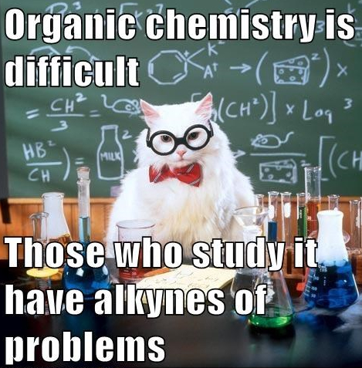

MULTIPLE CHOICE ANSWER SHEET

Instruction

For each question shade the box to indicate your answer.
Use only a blue or black pen to shade the boxes.

For example, if b is your answer: a□ b  c □ d □

If you make a mistake, place a cross through that square then shade your new answer.
Do not erase or use correction fluid.


For example, if b is a mistake and d is your answer: a □ b  c □ d 

If you then want to use your first answer b, cross out d and then circle b.




a□ b  c □ d 

Marks will not be deducted for incorrect answers. No marks will be given if more than one answer is completed for

Questions 1-10

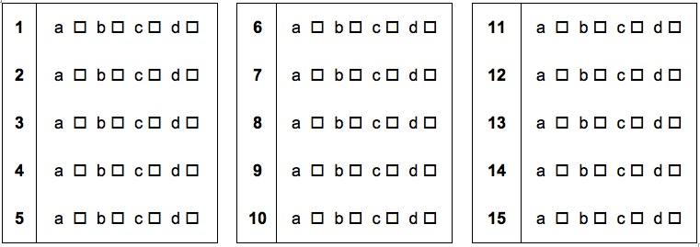

MULTIPLE CHOICE SECTION

1. The molecule represented by the following structural formula is citral or lemon grass oil.

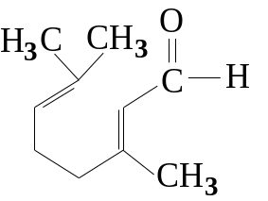
Citral is:
(A) an aldehyde
(B) a carboxylic acid
(C) a ketone
(D) an ester

2. The IUPAC systematic name for the compound whose structure is given below is
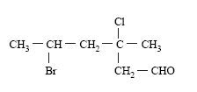
(A) 2-bromo-4-chlorohexanal
(B) 3-chloro-3-methyl-5-bromohexanal
(C) 5-bromo-3-chloro-3-methylhexanal
(D) 2-bromo-4-chloro-4-methylhexanal

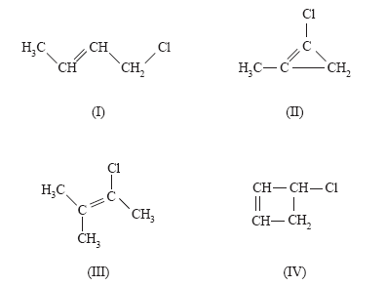
3. Which of the following represent a pair of isomers?

(A) I and II
(B) I and III
(C) I and IV
(D) II and IV

4. Which of the following pairs of substances are NOT isomers?

(A) pentan-2-one and 3-methylbutanal
(B) butanoic acid and propyl methanoate
(C) cyclopropanol and propanone
(D) methylcyclopentane and hexane.
5. Which of these substances can be oxidised to produce propanoic acid?

(A) propan-2-ol
(B) propanone
(C) propanal
(D) propene

6. Y is a liquid which burns with a yellow flame. When it is warmed with dilute acidified potassium dichromate, the colour of the solution changes from orange to green. Which of the following could Y be?
(A) butanoic acid
(B) 1-butanol
(C) 2-methylpropan-2-ol
(D) butane

7. Cinnamic acid is an organic substance that partly contributes to the flavour of oil of cinnamon.
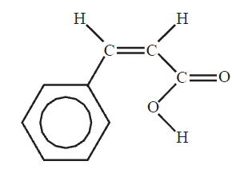
A structure of cinnamic acid is given below.

Which of the following reagents would you expect to react with cinnamic acid under the conditions given below?

Br₂(aq) at room temperature NaOH solution at room temperature Liquid CH₃OH and H₂SO₄

A Yes Yes Yes
B Yes No Yes
C No Yes Yes
D No No No

8. Lipids are naturally occurring compounds in the human body. Their main functions include energy storage and cell structure.

A structure of a typical lipid molecule is given below:

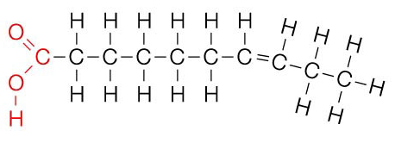

Based on the structure shown above, it can be predicted that this molecule is

(A) equally soluble in both oils and water
(B) more soluble in water than oils
(C) more soluble in oils than in water
(D) none of the above

9. A compound associated with the smell or flavour of raspberries has the structure

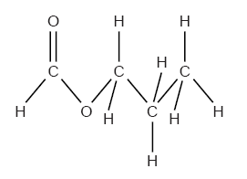
To produce this compound in the laboratory you would react

(A) methanol and propanoic acid in the presence of concentrated sulphuric acid.
(B) 1-propanol and methanol in the presence of concentrated sulphuric acid.
(C) 1-propanol and methanoic acid in the presence of concentrated sulphuric acid.
(D) 1-methylethanol and methanoic acid in the presence of concentrated sulphuric acid.

10. The boiling point of a family of trihalomethanes (CHX₃) are listed below.

Trifluoromethane CHF₃ -89ºC
Trichloromethane CHCl₃ 61ºC
Tribromomethane CHBr₃ 150ºC
Triiodomethane CHI₃ 330ºC

The increase in boiling points down the group is due to an increase in the strength of
- covalent bonds
- dispersion forces
- dipole-dipole attraction
(D) hydrogen bonds

PART 2: SHORT ANSWER

1 Two different compounds A and B are isomers with the molecular formula C₃H₈O.

LiquidsA and B undergo a series of reactions as shown below.
B

C₃H₈O
A

C₃H₈O

acidified K₂Cr₂O₇ is added& heat applied acidified K₂Cr₂O₇ is added& heat applied

C

C₃H₆O₂
E

C₃H₆O

a little CH₃CH₂OH is added

D

C₅H₁₀O₂

(A) Give the structural formula for

Compound D | Compound E
[2 marks]

2. Sorbic acid, CH₃(CH)₄COOH, has antimicrobial properties that are used to inhibit yeast and mould growth. However, its solubility is very low. The more soluble potassium sorbate is used instead. The antimicrobial activity of sorbic acid is retained because an equilibrium exists according to the equation:

CH₃(CH)₄COO⁻_{(aq)} + H₂O_{(l)} → CH₃(CH)₄COOH_{(aq)} + OH⁻_{(aq)}
(sorbate ion) (sorbic acid)
How would the addition of a small amount of 1.0 mol/L hydrochloric acid affect the concentration of sorbic acid in solution? Justify your answer in terms of equilibrium principles.

____________________________________________________________________________________________________

____________________________________________________________________________________________________

____________________________________________________________________________________________________

____________________________________________________________________________________________________

____________________________________________________________________________________________________
[2 marks]
3. The chemical ‘Paser’is an anti-tuberculosis drug used to treat tuberculosis in combination with other active agents. It is most commonly used in patients with Multi-Drug-Resistant Tuberculosis. Common side effects include nausea, vomiting, diarrhea, and abdominal pain.
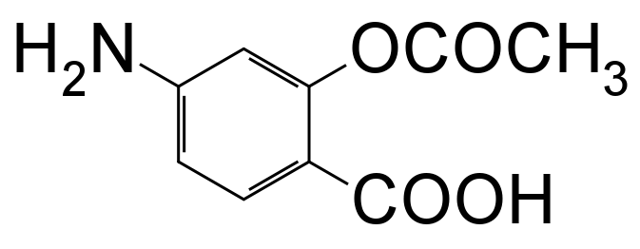

(A) On the structural formula above, circle and name any two (2) functional groups. [1 mark]

(B) Draw the resultant structural formula of the organic product formed when Paser undergoes a reaction with dilute ammonia solution.

[1 mark]

(C) From the structure of Paser, briefly discuss the suitability of Paser as an acid-base buffer.

_________________________________________________________________________________________

_________________________________________________________________________________________

_________________________________________________________________________________________

_________________________________________________________________________________________

_________________________________________________________________________________________

_________________________________________________________________________________________

_________________________________________________________________________________________
[2 marks]

4. Propanoic acid (also known as propionic acid), CH₃CH₂COOH is a clear, colourless liquid with a slightly sweetish odour. It is soluble in water and alcohol; melts at -21º C, boils at 141ºC. It is used as a preservative in feed and food industry directly or in the forms of ammonium propionate, calcium and sodium propionates.

A) Draw and name two structural isomers of C₃H₆O₂ (other than propanoic acid).

[2 marks]
Other uses of propanoic acid include the manufacture of various propionates which are used in the production of pharmaceuticals, antifungal agents, agrochemicals, plastics, plasticizers, rubber chemicals, dyes, solvent and in nickel-electroplating solutions. It is also used in the manufacturing of artificial flavours and synthetic perfumes.

Propanoic acid can undergo esterification with pentan-1-ol, CH₃CH₂CH₂CH₂CH₂OH, to produce an apple-like odour.

B) Write the structural formula for the product formed by the reaction between propanoic acid and pentan-1-ol.

[1 mark]

5. Complete the following table by naming or drawing the structural formula

Structural formula | Name
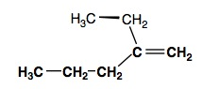

 | 4-iodobutanone
[2 marks]

6. The molecule methyl 2-methylpropenoate, shown below, is the monomer for the polymer commonly known as Perspex.

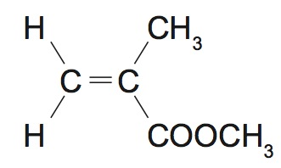
Draw the structural formula of the polymer Perspex showing two (2) repeating units.

[2 marks]

7. A polyester polymer was analysed to determine its empirical formula. Combustion of a 9.76 g sample of the polyester in excess oxygen produced 17.9 g of carbon dioxide and 4.88 g of water.

- If the polymer contains only carbon, hydrogen and oxygen atoms then calculate its empirical formula. [5 marks]

The polymer was then hydrolysed using sulfuric acid to split it into the diol and dicarboxylic acidmonomers used in its preparation. The flow diagram below illustrates this.

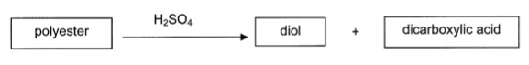

2.20 g of the dicarboxylic acid monomer was isolated and dissolved in 250.0 mL of distilled water. 50.0 mL of the dicarboxylicacid solution required 15.3 mL of 0.487 molL⁻¹sodium hydroxide solution for complete neutralization.
- Calculate the molar mass of the dicarboxylic acid monomer. [3 marks]

- Given the information from part (B), deduce and draw a possible structure of the dicarboxylic acid if the percentage by mass of carbon in the dicarboxylic acid is 40.7%. [2 marks]

END OF TEST
Laboratory Test: Alcohols (20 marks)

Answer the following questions based on Experiments 25 and 26

- What colour change was observed when:

(a) an aqueous solution containing acidified sodium dichromate was added to a primary alcohol? (1 mark)

from_______________________________ to ______________________________

(b) an aqueous solution containing acidified potassium permanganate was added to a secondary alcohol? (1 mark)

from_______________________________ to ______________________________

- (a) Draw the structure of the organic product formed when each of the following was treated with excess acidified
dichromate and provide IUPAC names for them. (5 marks)

Reactant | Structural formula of product(if any) | IUPAC name of product (if any)
ethanol

butan-2-ol

2-methylpropan-2-ol

- Write a balanced chemical equation for the reaction that occurred when excess potassium permanganate was added to butan-1-ol. (3 marks)

________________________________________________________________________________________________

________________________________________________________________________________________________

________________________________________________________________________________________________

(c) State one (1) observable change with this reaction. (1 mark)

________________________________________________________________________________________________

- An ‘orange’ odour was produced when octan-1-ol was added to ethanoic acid in the presence of concentrated sulphuric acid.

- Draw the structure of the organic product formed. (1 mark)

- Why was sulphuric acid used in this experiment? (1 mark)

________________________________________________________________________________________________

- State the chemical formula of the non-organic product formed in this reaction. (1 mark)

________________________________________________________________________________________________
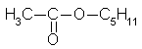
The structural formula of the ester responsible for the odour of pear is:

- Draw the structural formula of the organic reactants required to make the ester above. (2 marks)

- Provide a brief reason as to why each of the following steps was performed during the oxidation of alcohols experiments.

- H₂SO₄ was added to the Na₂Cr₂O₇ and to the KMnO₄solutions before they were added to the alcohols. (1 mark)

________________________________________________________________________________________________

________________________________________________________________________________________________

- The alcoholand Na₂Cr₂O₇mixtures were placed in a hot water bath for up to 5 minutes. (1 mark)

________________________________________________________________________________________________

________________________________________________________________________________________________

- The oxidation of alcohols experiment posed some quite hazardous situations that could possibly occur.
Briefly describe two possible dangerous situations and the steps taken to prevent them from happening.
(2 marks)

i.______________________________________________________________________________________________

________________________________________________________________________________________________

ii.______________________________________________________________________________________________

________________________________________________________________________________________________

END OF LAB TEST

